**CHAPTER THREE**

**MATERIALS AND METHODS**

**3.1 Design and Analysis**

In this section, the various block/units and their circuit diagrams, design analysis, criteria and assumptions made for component selection are presented. Figure 3.1 shows the functional blocks of the designed circuit.

MCU

0-30v OUTPUT

Switch Unit

POT

Power Supply

Feedback

12V AC OUTPUT

T

-15V DC OUTPUT

T

15V DC OUTPUT

T

5V DC OUTPUT

T

Legend

Power

Data

**Figure 3.1:** Bock diagram of the multiple power supply system

**3.1.1 Power Supply Unit**

This unit converts the 220V AC to 12V AC , 30V DC required by the circuit. It was implemented with the following components:

• 220V/15-0-15V step down transformer

• 220V/12-0-12V step down transformer

• Bridge Diode

• Capacitor

• Voltage regulator

Below is the circuit diagram of the power supply unit:

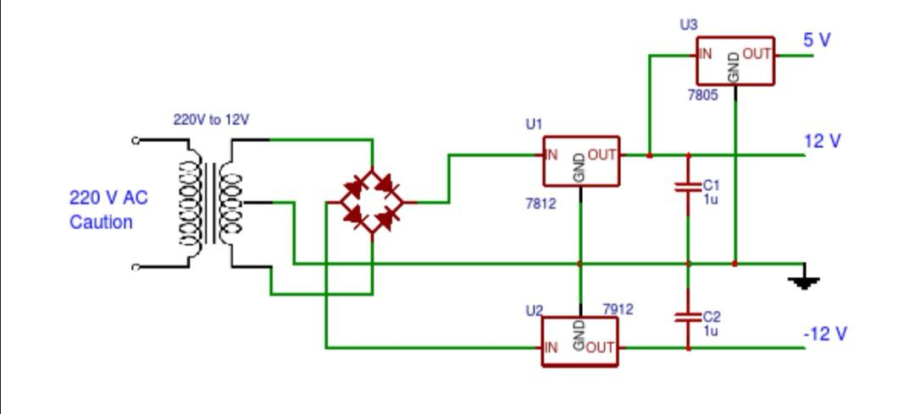

# **Fig. 3.1: Power Supply Unit**

**Voltage Regulator:**

As we require a 5V,15V,-15V we need LM7805,LM7815,LM7915 Voltage Regulator IC.

7805 IC Rating:

• Input voltage range 7V- 35V

• Current rating IC = 1.5A

• Output voltage range Vmax=5.2v, Vmin=4.8v

7815 IC Rating:

• Input voltage range 15V- 45V

• Current rating IC = 1.5A

• Output voltage range Vmax=15.2v, Vmin=14.8v

7915 IC Rating:

• Input voltage range -15V- (-45V)

• Current rating IC = 1.5A

• Output voltage range Vmax=-15.2v, Vmin=-14.8v

**Transformer:**

Selecting a suitable transformer is of great importance. The current rating and the secondary voltage of the transformer is a crucial factor.

• The current rating of the transformer depends upon the current required for the load to be driven.

• The input voltage to the 7815 and 7915 IC should be at least 2V greater than the required 15V output, therefore it requires an input voltage at least close to 17V.

• So, we chose a 15-0-15V transformer with current rating 1500mA (Since 15*√2 = 21.21V).

**Rectifying circuit:**

The bridge rectifier converts the ac voltage input to dc voltage at its output. The diodes IN4007 was used. The best is using a full wave rectifier due to the following good qualities:

• Its DC saturation is less, as in, both cycle diodes conduct.

• Higher Transformer Utilization Factor (TUF).

• 1N4007 diodes are used as it is capable of withstanding a higher reverse voltage of 1000v whereas 1N4001 is 50V.

• Center Tap Full Wave Rectifier.

The choice of the bridge rectifier depends on:

i. Peak inverse voltage.

ii. The forward current rating

The diode forward current rating is the maximum that the diode can conduct before failing. The diode should be selected in such a way that the current passing through it should be less than the forward current rating. The peak inverse output is the reverse voltage that the diode has to block when not conducting.

Peak Inverse Voltage (PIV) = $\sqrt{2 } ×Vrms$

­

where Vrms  = transformer output = 15Vac

* Peak inverse voltage = $\sqrt{2 }$ x 15 = 16.97v
* The diodes used has forward current ≥ 1500mA and PIV ≥ 21.21V

**Selection of the Filter Capacitor (C1):**

The filter capacitor smoothens the dc voltage from the bridge rectifier.

The choice depends on:

i. The capacitor breakdown voltage

ii. The ripple percentage required

Capacitor breakdown voltage (Vc) is gotten by taking KVL from the bridge rectifier output to capacitor terminal. Using Fig. 3.1

Vpeak – Vd – Vc = O

Where Vpeak = bridge rectifier output

Vd = drop across bridge rectifier diodes

Vc = capacitor terminal voltage

21.21v – 1.4v – Vc = 0 ------------- (3.1)

For full wave rectification, on each half section, 0.7 is drop across each of the two conducting diodes. Which gives 1.4v (2 x 0.7v)

equation (3.1) becomes

19.81 – Vc = 0

where Vc = 19.81V

In practices, the rule is to use a capacitor with breakdown voltage double of the terminal voltage:

V1c = 2 x Vc

V1c = 2 x 19.81

= 39.62V

A standard value of 50V was used.

**Capacitor Capacitance:**

$C=I load÷2fV∆$ for full wave

Where VΔ is the difference between the maximum peak voltage and the minimum peak voltage.

Maximum peak = 21.21v

Minimum peak = 21.21 - % ripple

% ripple = 21.21 – minimum peak

taking minimum peak = 19.21v

% ripple = (21.21 – 19.21) v = 2v



A standard value of 2500uf capacitor was used.

## 3.1.2 **THE CONTROLLER UNIT**

This Unit is the Heart of the Entire System. It performs the entire logic of the system. Below is the requirements of the controller unit.

**Requirements of the Controller**

* Should be able to interface analog signal(ADC).
* Should have PWM Module required to interface the feedback system
* Should be stable and efficient.
* Should have enough Input/output Pins to accommodate the entire system.
* Should be easily programmed.
* It should available and cost effective.

**Selection of the Controller**

The Atmega328p Microcontroller From Microchip Corporation was selected. Below are the reasons of the selection.

* It is a 28pin Microcontroller, it has enough input/output pins.
* A pin in the microcontroller can supply 5V 20mA.
* It has internal ADC Module Required to interface the LM324 IC
* It Has UART Serial communication Module
* It has an easy programming interface.
* It is stable, cost effective and available.

The Atmega328p Microcontroller was biased with a 16Mhz Crystal and two (2) 15pf Capacitors.

**To determine the time the microcontroller executes one instruction**

One machine cycle is the time taken to execute an instruction

Machine cycle = 4 pulses of crystal oscillator.

Hence, time taken = Oscillator Frequency

4

For one machine cycle

= 16MHZ = 4MHZ

4

1/F= 1/4MHZ = 1μs

The controller executes one instruction in 1 micro seconds.

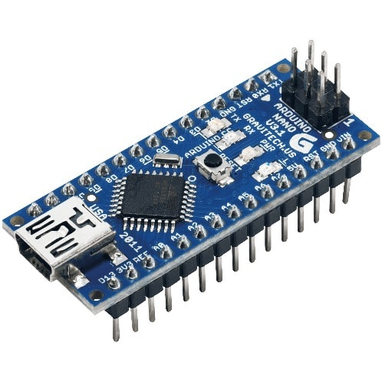

**Figure 3.2:** The circuit diagram of micro controller unit

## 3.1.2 **The Feedback unit**

The feedback circuit uses an LM324 op-amp to provide a feedback signal to the Arduino Nano’s analog input pin from a 0-30V DC source involves scaling down the voltage to a level that the Arduino Nano can safely read. The Arduino Nano's analog inputs can only read voltages between 0 and 5V, so will need to use a voltage divider and LM324 for feedback control, such as voltage sensing, regulation, or monitoring.

* **Key Elements of the Circuit:**

Voltage Divider: To scale the 0-30V DC input down to a 0-5V range.

LM324: Acts as a buffer or comparator to condition the voltage for more precise readings.

Arduino Nano: Reads the scaled voltage via an analog input pin (A0) for further processing or decision-making.

Design steps

* Voltage Divider (Scaling 30V to 5V)

Since the Arduino Nano can only read up to 5V, you must use a voltage divider to scale the 0-30V down to a range of 0-5V. The voltage divider consists of two resistors:

- The scaling factor for a 0-30V to 0-5V transformation is

( 5V/30V = 1/6 ).

To design this:

* Select two resistors, R1 and R2 , such that the output voltage across R2 is 1/6th of the input voltage.

The ratio of the resistors is determined by:

Vout/Vin = R2/(R1 + R2)

For example, using R1 = 25k and R2 = 5k gives:

5k/(25k + 5k) = 1/6

This scales the input voltage (0-30V) to a range of 0-5V.

**Buffering with LM324**

Using the LM324 as a buffer (unity-gain configuration) helps isolate the voltage divider from the Arduino Nano’s analog input, improving accuracy and ensuring that the impedance of the divider doesn't affect the readings.

Here’s how to configure the LM324 as a buffer:

* Connect the non-inverting input of one of the LM324’s op-amps (pin 3) to the output of the voltage divider (the node between R1 and R2 .
* Connect the inverting input (pin 2) directly to the output of the op-amp (pin 1), creating a unity-gain buffer.
* Connect the op-amp’s output (pin 1) to the Arduino Nano’s analog input pin (e.g., A0).

This configuration ensures the voltage reading from the divider is passed to the Arduino without any loading effects from the Nano’s analog pin.

Optional: Comparator Using LM324 (For Voltage Monitoring)

If you want to use the LM324 for voltage monitoring (e.g., detecting when the voltage exceeds a threshold), you can configure it as a comparator:

- Non-inverting input: Connect this to the voltage from the divider (scaled 0-5V).

- Inverting input: Set a reference voltage using a voltage divider(e.g., a fixed 2.5V) to compare against.

- Output: If the input voltage exceeds the reference voltage, the LM324 will output a high signal, which you can send to a digital pin of the Arduino Nano for detection.

Connecting to Arduino Nano

* Connect the output of the LM324 buffer to one of the Arduino Nano’s analog input pins (e.g., A0).
* The Arduino Nano will read the voltage (0-5V) and map it to the corresponding original voltage (0-30V) using the `analogRead()` function, which returns values between 0 and 1023.

To calculate the original voltage from the analog reading:

Vin = analogRead(A0) x 30/1023

Example Arduino Code to Read and Map Voltage

int analogPin = A0; // Pin connected to the output of the LM324

float voltage = 0.0;

int rawValue = 0;

void setup() {

Serial.begin(9600);

}

void loop() {

rawValue = analogRead(analogPin); // Read the analog input

voltage = rawValue * (30.0 / 1023.0); // Convert the reading to 0-30V

Serial.print("Input Voltage: ");

Serial.println(voltage);

delay(1000); // Update every second

}

**CHAPTER FOUR**

**4.1 Construction**

In this chapter, we shall be treating the construction of this project work. We shall be covering the details involved in the construction of the multiple output source power supply from the measurements to the commissioning of the system. Alongside this, we shall also be treating the precautions taken in the construction of the system.

**4.1 Componets and their specification**

**4.1.2 Tools and Materials**

i. PC

ii. Switch

iii. Casing

iv. power cord

v. Drilling machine

vi. Handsaw

vii. Tape

viii. Multimeter

ix. Screw drivers

x. Plier

**4.4 STEPS IN THE CONSTRUCTION OF THE Power Supply**

In this section, we shall be treating the various steps taken in the construction of the system.

1. Construction of the casing
2. Installation of the components
3. Preparation of the PC
4. Wiring of the components
5. Commissioning of the system

**4.5 PREPARATION OF THE PC**

At this stage, having purchased our Personal computer (the computer) following the consideration in chapter 3. The following steps were observed in preparing the PC for the control job:

1. The PC was powered ON
2. The PC was properly booted
3. The Arduino Developer software was installed on the PC using the software disk and following the installation procedure.
4. The program was run on the PC
5. A test program was written and stimulated on the Proteus Simulator.

**4.1.3 Method of Construction**

* **Testing of individual components**

Testing LM7815, LM7915, LM7805, Bridge Rectifier,LM324,Arduino and Mosfet

### **Bridge Rectifier Testing**

* **Visual Inspection:** Check for physical damage, burnt components, or loose connections.
* **Continuity Test:** Use a multimeter in diode mode to check the continuity between each pair of opposite terminals. The meter should show a forward voltage drop (around 0.7V) in one direction and a high resistance in the other.

### **Voltage Regulator Testing**

#### Positive Regulators (LM7815, LM7805)

* **Input Voltage:** Connect the input terminal of the regulator to the positive terminal of the power supply.
* **Ground Connection:** Connect the common (ground) terminal of the regulator to the negative terminal of the power supply.
* **Output Load:** Connect a load resistor (e.g., 1000 ohms) between the output terminal of the regulator and the ground.
* **Voltage Measurement:** Measure the voltage across the load resistor using a multimeter. It should be equal to the regulated output voltage of the regulator (15V for LM7815, 5V for LM7805).

#### **Negative Regulator (LM7915)**

* **Input Voltage:** Connect the input terminal of the regulator to the negative terminal of the power supply.
* **Ground Connection:** Connect the common (ground) terminal of the regulator to the positive terminal of the power supply.
* **Output Load:** Connect a load resistor (e.g., 1000 ohms) between the output terminal of the regulator and the ground.
* **Voltage Measurement:** Measure the voltage across the load resistor using a multimeter. It should be equal to the regulated output voltage of the regulator (-15V for LM7915).

#### LM324 Op-Amp

* **Power Supply:** Connect the LM324's Vcc pin to a positive voltage (e.g., 5V from the Arduino Nano) and the Vss pin to ground.
* **Input Signal:** Apply an input signal to one of the op-amp's inputs (e.g., from a function generator or potentiometer).
* **Output Measurement:** Measure the output voltage using a multimeter. The output voltage should be amplified or inverted depending on the op-amp's configuration (e.g., inverting amplifier, non-inverting amplifier).
* **Verify Functionality:** Test different op-amp configurations (e.g., inverting, non-inverting, differential) to ensure each op-amp is working correctly.

#### Arduino Nano

* **Basic Functionality:** Program the Arduino Nano to perform simple tasks (e.g., blinking an LED, reading a sensor).
* **Serial Monitor:** Use the Arduino IDE's serial monitor to communicate with the Arduino and verify its output.
* **Pin Testing:** Test individual pins to ensure they are functioning correctly.

#### MOSFET

* **Power Supply:** Connect the MOSFET's gate, drain, and source pins to the appropriate voltage levels (e.g., gate to a digital output pin on the Arduino, drain to a load, source to ground).
* **Control Signal:** Apply a control signal (e.g., a digital high or low) to the gate pin.
* **Load Measurement:** Measure the current flowing through the load to verify if the MOSFET is switching on or off.
* **Verify Functionality:** Test the MOSFET in different configurations (e.g., common source, common drain) to ensure it's working correctly.

**• Building of circuit on breadboard and testing.**

### Steps for Wiring:

#### Step 1: Step-Down Transformer (AC to Lower AC)

* Connect the **primary side** of the step-down transformer to the AC mains supply (ensure safety precautions when working with mains).
* The **secondary side** of the transformer will provide a low AC voltage (e.g., 12V AC).
* Use of jumper wires to connect the secondary side of the transformer to the breadboard.

#### Step 2: AC to DC Conversion (Bridge Rectifier)

* Connecting of four diodes (e.g., 1N4007) to form a **bridge rectifier**:
* Two diodes was connected in series to form the positive output.
* Two diodes was be connected in reverse for the negative output.
* Connect the AC output from the transformer to the bridge rectifier input terminals (AC).
* The output will be DC, with some ripple.

#### Step 3: Filtering the DC Output

* To smooth the rectified output, a large **capacitor was connected** (e.g., 25000µF, 50V) across the output of the rectifier. This will help reduce the ripple.
* It produces a more stable DC voltage (but still unregulated).

#### Step 4: Voltage Regulation

* **voltage regulators** like 7805 for 5V output and 7815 for 15V output.
* Connect the **input** of the regulator to the rectified DC voltage.
* Connect the **ground** pin to the ground rail of the breadboard.
* The **output** pin will provide regulated voltage.
* Place both 7805,7915 and 7815 on the breadboard to have two regulated voltage rails (e.g., 5V , -15V and 15V) for different circuits.

#### Step 5: Wiring the Arduino Nano

* Power the **Arduino Nano** using the 5V regulator (7805). Connect the **5V output** of the 7805 to the **5V pin** of the Arduino Nano.
* Connect the **ground** of the breadboard to the **GND pin** of the Arduino Nano.

#### Step 6: MOSFET as a Switch (Optional)

* Use an **N-channel MOSFET** (e.g., IRF540) for switching high current loads:
* Connect the **source** pin of the MOSFET to ground.
* The **drain** pin will connect to the negative side of the load.
* The **gate** pin can be connected to a PWM pin of the Arduino Nano (e.g., D9) through a current-limiting resistor (e.g., 220Ω).
* The Arduino Nano can control the MOSFET gate to switch the load on and off.

#### Step 7: Using the LM324 for Voltage Sensing or Signal Amplification (Optional)

* The **LM324** can be used in various ways in this circuit, for example, as a voltage comparator to monitor power supply levels or as a signal amplifier.
* To use it as a comparator:
* Connect one input of the op-amp to the voltage you want to monitor (e.g., the output of the 7805).
* The other input can be connected to a reference voltage (set by a voltage divider).
* The output of the op-amp can be fed to an Arduino Nano input pin for voltage monitoring.

#### Step 8: Testing and Debugging

* After completing the connections, power on the circuit by connecting the mains supply.
* Measure the output of the regulators to ensure you're getting stable 5V,-15V and 15V.
* Test the MOSFET switching by controlling it with the Arduino Nano.
* If using the LM324 for monitoring, ensure it is properly detecting voltage levels and providing accurate output to the Arduino Nano.

**4.1.4 CONSTRUCTION OF THE CASING**

In this section, we shall be treating the various steps taken in the construction of our casing after having selected our material following steps as listed in chapter 3. They are:

1. The material was measured using a tape and a meter rule.
2. The required shapes and sizes were marked using a pencil.
3. The marked areas were cut out using saw and cutter
4. The cut material was joined using gum and screw.
5. Excessive material was removed using and file and sand papering tool.

## 4.2 TESTS AND RESULTS

The following tests were carried out and the following results were obtained:

**Table 4.1: Test and Result**

|  |  |  |  |  |
| --- | --- | --- | --- | --- |
| **Test** | **Aim** | **Equipment**  **used** | **Result** | **Conclusion** |
| Firmness test. | To ensure all components were tightly installed in the casing | Slight pulling | All the components were firmly installed as none pulled | All components were properly installed |
| Open Circuit test | To ensure there is no open circuit on the wiring done from one component to another | Digital Multimeter | All the test points read R>1Ω | There is no open circuit in the connection therefore the connection was properly done |
| Insulation test | To ensure there is no leakage current from any of the components to the casing of the training kit | Digital Multimeter | There was no continuity at all the test point which means there is no leakage current | There is no leakage current therefore insulation is perfect. |
| Short Circuit Test | To ensure there is no short circuit on the wiring done from one component to another. | Digital Multimeter | All the test points read R>1Ω. | There is no short circuit in the connection therefore the connection was properly done |
| Operation test | To ensure the system was working efficiently | The system was powered ON and the programs were run and were observed on the training kit. | Operated as required | System is in good operating condition. |

**Table 4.2: Bill of engineering material**

|  |  |  |  |  |
| --- | --- | --- | --- | --- |
| **S/N** | **DESCRIPTION OF ITEM** | **QTY** | **UNIT PRICE (N)** | **TOTAL PRICE**  **(N)** |
| 1 | Arduino Nano | 1 | 35,000.00 | 35,000.00 |
| 2 | Switch | 1 | 150.00 | 150.00 |
| 3 | Mosfet | 1 | 5000.00 | 5000.00 |
| 4 | Voltage Regulator | 4 | 500.00 | 2000.00 |
| 5 | Casing | 1 | 35,000.00 | 35,000.00 |
| 6 | Power supply Cord (power pack) | 1 | 800.00 | 800.00 |
| 7 | LM324 | 1 | 8000 | 8000 |
| 8 | POT | 1 | 1000 | 1000 |
|  | **TOTAL** |  | **174,000.00** | **190,000.00** |

**CHAPTER FIVE**

**5.0 CONCLUSION AND RECOMMENDATION**

In this chapter, we shall be focused on the conclusion of the Multiple power supply and possible recommendations for future works in this field. We shall be taking a brief look on the entire project work before concluding this work.

**5.1 CONCLUSION**

Just as the desire to be an Engineer and solve problems has been born in us over years so has the need for a better industrial instrument, a better teaching tool been needed in the petroleum training institute. This project work has been targeted in solving the problem of better practical power supply aid in the Electrical Engineering Department of the Petroleum training Institute Effurun, Delta State.

Starting from the chapter one, we took out time to clearly declare what this project shall be all about alongside the scope of the construction of this power supply. After we were done with this, we went further to in the chapter two of this work take a look at related works that has been done in this field trying to understand their scopes and their limitations to further know the best needs to focus on in the construction of this power supply so it would not just be a repetition of previous engineering works but instead an improvement to the area of control engineering.

Having understood other jobs in this area, we went ahead to in our chapter three design our desired project work. In this chapter we had made a selection of all the components that shall be used in the construction of this work and also the reasons for these selections was properly done. We went ahead to in the chapter 3 of this work describe in as much details as possible the steps followed in the construction of this project along side with the various tests that have been carried out to ensure the reliability of this construction and its efficiency.

Finally, considering the work flow from the chapter one to this current stage, we shall conveniently declare the successfully conclusion of this power supply.